

REPUBLIC OF TURKEY MINISTRY OF ECONOMY
GENERAL DIRECTORATE OF INCENTIVE IMPLEMENTATION AND FOREIGN
INVESTMENT

INTERNATIONAL DIRECT
INVESTMENT CLIMATE IN TURKEY

November, 2012

For further inquiries: info@yoikk.gov.tr

OUTLINE

✓ Scope and Definition of FDI in Turkey

✓ Basic Principles Concerning FDI Regime in Turkey

✓ Company Registration

✓ Real Estate Acquisition of Foreigners

✓ Work Permits

For further inquiries: info@yoikk.gov.tr
DEFINITION OF FOREIGN INVESTOR

Foreign Investor
✓ Foreign real persons

✓ Turkish nationals resident
abroad

✓ Foreign legal entities established under the laws of foreign countries

✓ International institutions

For further inquiries: info@yoikk.gov.tr

DEFINITION OF FOREIGN DIRECT INVESTMENT

FDI
✓ Establishing a new company

✓Establishing a branch of a
foreign company,

✓Share acquisitions from a company established in Turkey

by a foreign investor

For further inquiries: info@yoikk.gov.tr

LIAISON OFFICES

✓ Facilitates business connections between the parent
(foreign) company and the firms in Turkey

✓ Initial operational permit for 3 years

✓ Possibility of extending operational permits

✓ Permitted fields of activity:

• Representation and hosting,

• Control, inspection and provision of local suppliers,

• Technical support,

• Communication and transfer of information,

• NEW CONCEPT- REGIONAL MANAGEMENT HEADQUARTERS:
START-UP PERMISSION FOR 10 YEARS

For further inquiries: info@yoikk.gov.tr
NEW TREND :

TURKEY AS A REGIONAL HEADQUARTERS FOR MULTINATIONALS

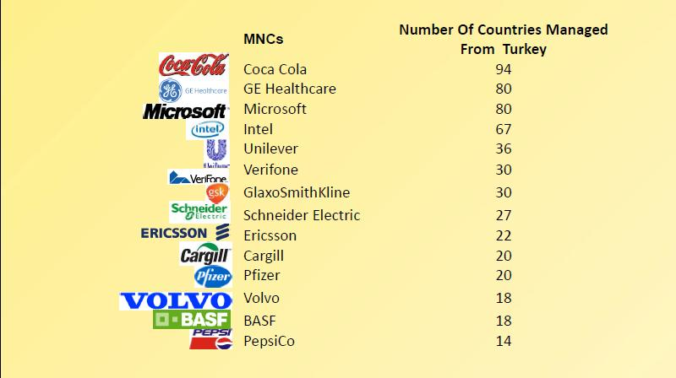

For further inquiries: info@yoikk.gov.tr 6

FDI REGIME: BASIC PRINCIPLES

FDI Regime
• National treatment
• No pre-entry screening /minimum capital requirements
• Right to acquire real estate
• Guarantee to free transfer of proceeds, dividends and other
financial assets.
• Right to employ key expatriate staff
• Right to access international dispute settlement

International Agreements
• Bilateral Investment Treaties with 85 countries
• Double Taxation Agreements with 76 countries
• Customs Union with the EU
• Free Trade Agreements with 19 countries

For further inquiries: info@yoikk.gov.tr 7
INTERNATIONAL AGREEMENTS

International Agreements – Spain

• Bileteral Investment Treaty

• Signature date : February 15, 1996
• Come into force: March 3, 1998


• Double Taxation Treaty

• Signature date : July 5, 2002
• Come into force: December 18, 2003

For further inquiries: info@yoikk.gov.tr
COMPANY REGISTRATION

✓ Company establishment in one day

✓ Starting and operating a business on equal terms with local investors within the context of the new Turkish Commercial Code

✓ All types of companies are allowed

✓ Significant cost and time advantages
comparing with the countries in the region

For further inquiries: info@yoikk.gov.tr
COMPANY REGISTRATION

Comparable Time and Cost of Starting A Business in Some
European Countries
35 32
30
30 28 28

25

20 18,2

15

10
6

5

0

18

1.8

15

4.6

17,3

2

20

8.4

4.7

5.2

11,2

6

Source: DB 2012 Report
Time Cost (%of income per capita)

For further inquiries: info@yoikk.gov.tr

COMPANY REGISTRATION

Company Statute and
Notarized signatures of founders

Deposit the initial capital in a bank
and the %00,4 of the capital
to the account of the Competition Authority

Register with the Trade Registry and
the Chamber of Commerce and/or Industry

Notarize Commercial Books

For further inquiries: info@yoikk.gov.tr
REAL ESTATE ACQUISITIONS BY FOREIGNERS: BASIC PRINCIPLES

3 different types of foreigners in terms of real estate acquisitions:

✓ Foreign Real Persons

✓ Foreign Companies

✓ Turkish Companies with foreign capital

Different Acquisition Regimes

For further inquiries: info@yoikk.gov.tr
REAL ESTATE ACQUISITIONS BY FOREIGNERS: BASIC PRINCIPLES

Foreign Real Persons
✓ Acquisition is possible for all nationalities
without requiring “reciprocity”
✓ Acquisitions up to 30 hectares
✓ The total area of real estates can not exceed 10% of the privately owned land in the town.
✓ Requirement to develop a project within two years in case the acquisition of a vacant land

Foreign Companies

For further inquiries: info@yoikk.gov.tr
✓ Acquisition of real estate within the context
of special laws such as Petroleum Law,
Tourism Encouragement Law, Industrial
Zones Law.

REAL ESTATE ACQUISITIONS BY FOREIGNERS: BASIC PRINCIPLES

Turkish Companies
With Foreign Capital

For further inquiries: info@yoikk.gov.tr
✓ No restriction on acquisition and
utilization of real estates to conduct
business activities listed in the Statute of
Company
✓ Permission requirement for the acquisitions in military zones and special security zones from the military authorities and province governorship respectively
✓ Permission requirement is necessary only for foreign capital companies controlled by foreign investors.

✓ Exemptions to specific cases for flexibility: Pledge on real estates, liquidation of pledges, mergers and divisions of companies, acquisitions in specific investment zones, acquisitions by banks for the collection of their receivables.

REAL ESTATE ACQUISITIONS BY

TURKISH COMPANIES WITH FOREIGN CAPITAL

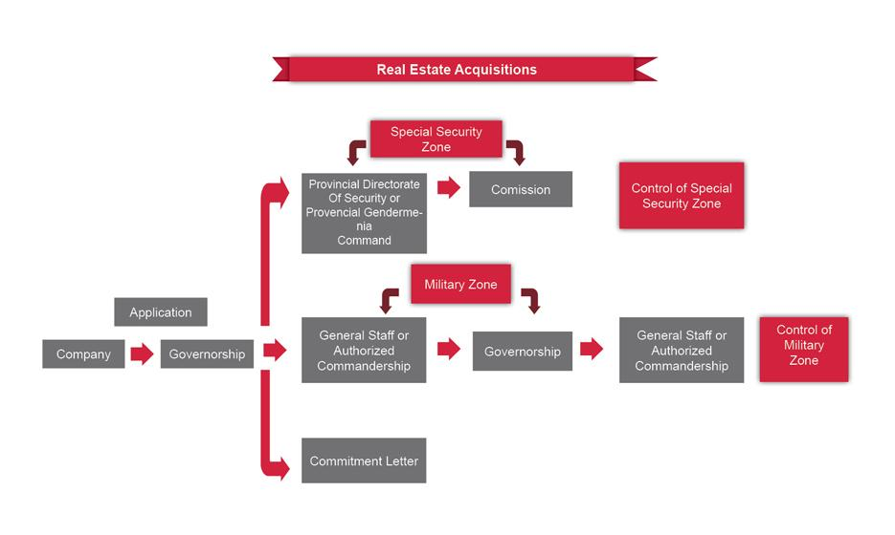

For further inquiries: info@yoikk.gov.tr
WORK PERMITS: BASIC PRINCIPLES

✓ Requirement to obtain a work permit before
starting to work in Turkey

✓ Opportunity to submit and process the
application electronically

✓ Various types of work permits depending on the status of the applicant

✓ 30-day statutory time limit to conclude the application

For further inquiries: info@yoikk.gov.tr
WORK PERMITS: PROCEDURES

Application to the
Ministry of Labor and Social Security in Turkey or from abroad

Conclusion of the evaluation process
within 30 days

Notification of the conclusion to the applicant and
the relevant public authorities (Governorship, the Ministries
of Interior and Foreign Affairs)

Application for the entry visa and the residence permit

For further inquiries: info@yoikk.gov.tr
Improving Investment Environment in Turkey

Improving investment climate : Moving target for the government since 2001

✓ Streamlining procedures for investments and eliminating administrative and bureaucratic hurdles in line with changing priorities and needs of business
✓ Political ownership
✓ Making full use of public-private dialogue through permanent
platforms:
▪ The Coordination Council for Improvement of Investment
Climate
▪ The Investment Advisory Council for Turkey

For further inquiries: info@yoikk.gov.tr 18
Structures for Improving Investment Environment in Turkey

COUNCIL OF MINISTERS

Coordination Council
for the Improvement of Investment Environment
(YOIKK)
Investment Advisory
Council
(IAC)

Monitoring (YOIKK Secretariat)


Steering Committee Working Groups for







Assesment and Evaluation

TECHNICAL COMMITTEES

Company registration and

Input Supply Strategy

Land for investment,

Taxes and

corporate governance
Employment
(GITES) and Sectoral
Licensing
environmental and
zoning permits
Incentives

Foreign Trade and Customs
Intellectual Property
Rights and R&D
Legislation of
Investment Climate

Access to Finance

Infrastructure

For more information: http://www.yoikk.gov.tr/eng

For further inquiries: info@yoikk.gov.tr

Structures for Improving Investment Environment in Turkey

Working Groups for Assesment and Evaluation

Aim:
Assess the effects of the completed activities of
YOİKK Technical Committees on investors

Groups:
Determined seperately for each assessment topic by YOİKK Steering Committee

Group Members:
• The Union of Chambers and Commodity Exchanges of Turkey (TOBB)
• The government body responsible from the assessment topic
• 3 other institution, given that YOİKK member NGOs are prioritized

Duty:
• Conduct Impact Assessment Studies on completed actions
• Report the data to the Steering Committee in two months

For further inquiries: info@yoikk.gov.tr
Structures for Improving Investment Environment in Turkey

Investment Advisory Council

✓ Executives of leading multinational firms,
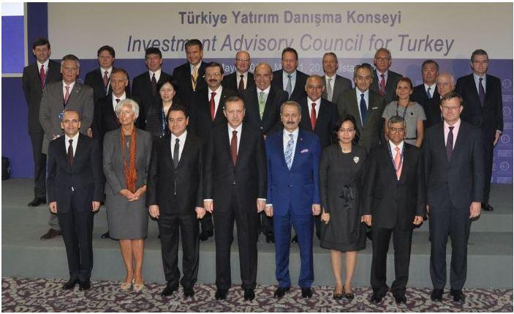

✓ Heads of international institutions (IMF, World Bank, European Investment Bank) and

✓ Heads of TOBB, TUSIAD, YASED, TIM.

Investment Advisory Council of Turkey had 7 meetings since 2004.

For further inquiries: info@yoikk.gov.tr


Contact Info:

Ministry of Economy

General Directorate for Incentive Implementation and

Foreign Investment

Ministry Phone: +90 312 204 6637

Counselor Phone:+34 91 310 4999

Fax: + 90 312 212 88 51

E-mail: info@yoikk.gov.tr

Web: www.economy.gov.tr

For further inquiries: info@yoikk.gov.tr

