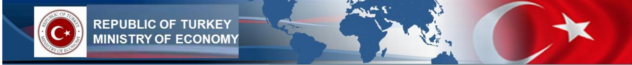

REPUBLIC OF TURKEY MINISTRY OF ECONOMY
GENERAL DIRECTORATE OF INCENTIVE IMPLEMENTATION AND FOREIGN INVESTMENT

TURKEY’S GENERAL ECONOMIC OUTLOOK
FOR INTERNATIONAL INVESTORS

November, 2012

For further inquiries: info@yoikk.gov.tr
Market Size

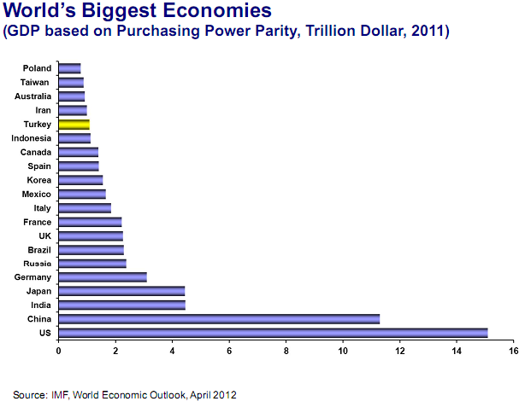

For further inquiries: info@yoikk.gov.tr 2
Growth Performance

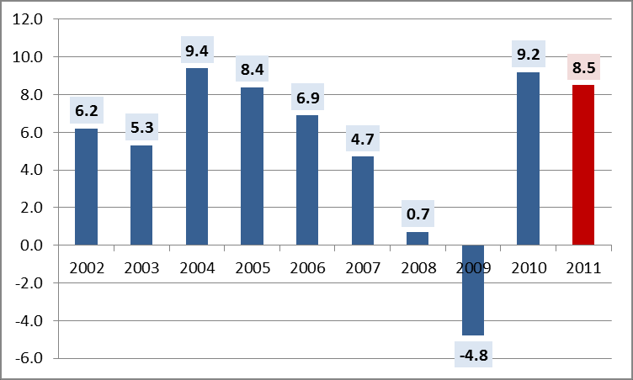

* Source:TURKSTAT

➢ Turkey has quickly recovered from the global financial crisis and among the least affected countries from current economic uncertainties
➢ Turkey has the highest economic growth rate in Europe
➢ Average annual growth rate between 2002 and 2011 is 6%
➢ Real GDP growth for 2011 has been realized as 8.5%
➢ Turkey has grown 3.2% in first quarter of 2012

For further inquiries: info@yoikk.gov.tr 3
Growth Performance

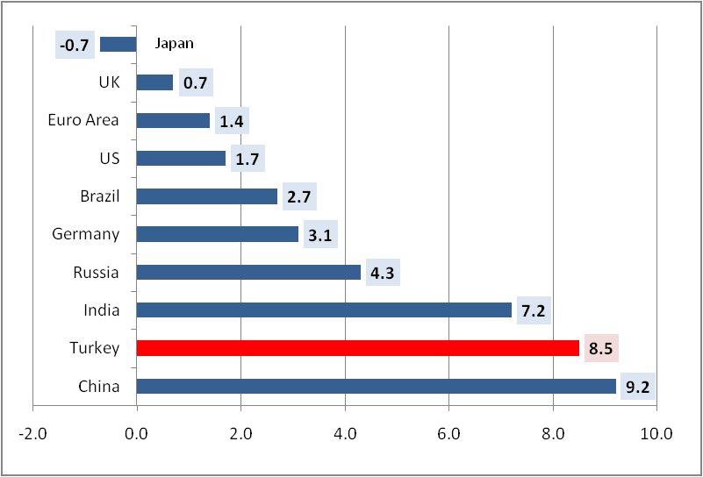

Source: TURKSTAT, IMF

➢ Turkish Economy expanded by 8.5% in 2011, which was well beyond the
forecasts of the IMF (7.5%).

For further inquiries: info@yoikk.gov.tr 4
Market Quality: GDP Per Capita

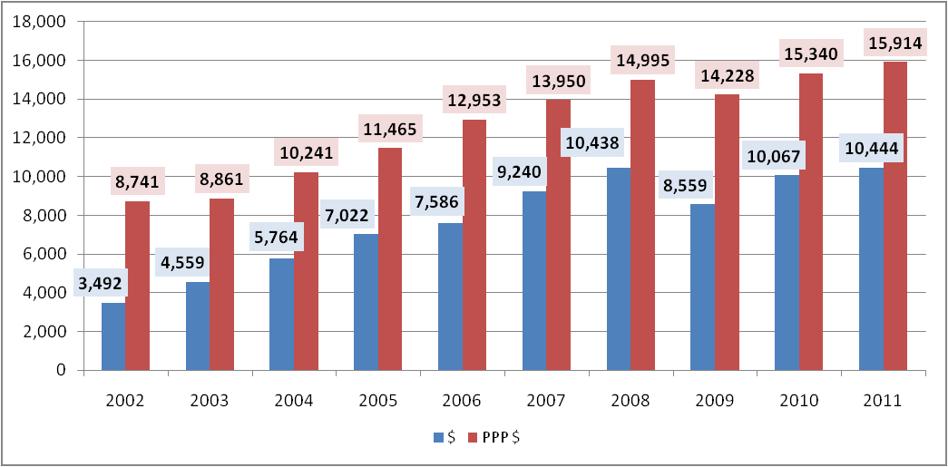

Source: TURKSTAT

➢ GDP per capita has tripled in the last eight years from 3,492 USD to 10,444 USD. According to Purchasing Power Parity (PPP),GDP per capita surpassed 15,000 USD.

For further inquiries: info@yoikk.gov.tr 5
Turkey: One of the Eight Growth Markets of Future

Growth
Markets

Brazil Russia India China Mexico Korea Turkey
Indonesia

Source: Goldman Sachs Asset Management, 2011

For further inquiries: info@yoikk.gov.tr
Market Quality: Favourable Demographics

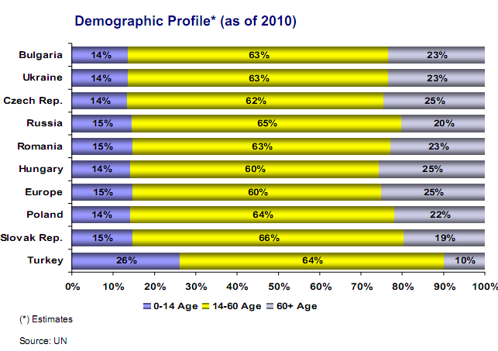

For further inquiries: info@yoikk.gov.tr 7
Market Quality: Favourable Demographics

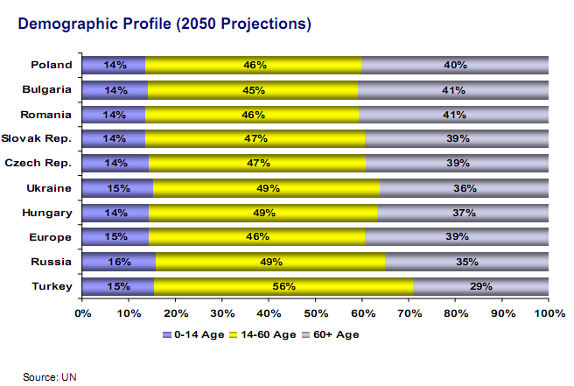

For further inquiries: info@yoikk.gov.tr 8
Labor Market: Employment

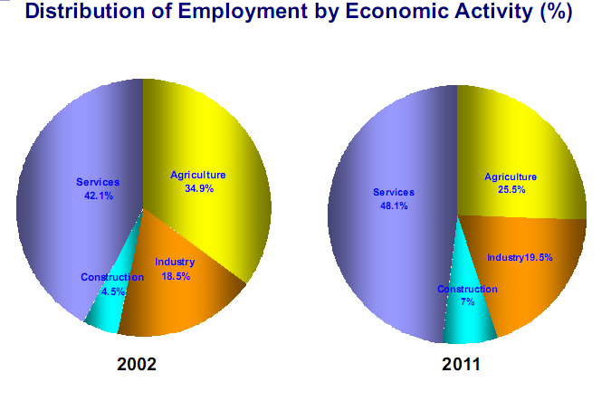

For further inquiries: info@yoikk.gov.tr 9
Labor Market: Unemployment

Source: TURKSTAT

➢ As of May 2012, the unemployment rate was 8.2% (seasonally adjusted unemployment rate was 9%).
➢ Seasonally adjusted unemployment rate in Euro Area was 11.3% and 10.4% in (EU27) as of July 2012. In terms of unemployment ratio Turkey outperformed 14 EU countries in July 2012.
➢ After Russia, Germany, England and France, Turkey has the 5th largest labor force among the European countries (2010, World Bank)

For further inquiries: info@yoikk.gov.tr 10
Investing in Turkey = Doing Business in the Region

4 - Hour

For further inquiries: info@yoikk.gov.tr 11
Inflation

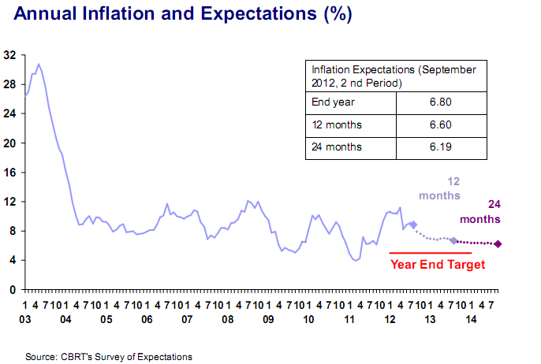

For further inquiries: info@yoikk.gov.tr 12
Industrial Production

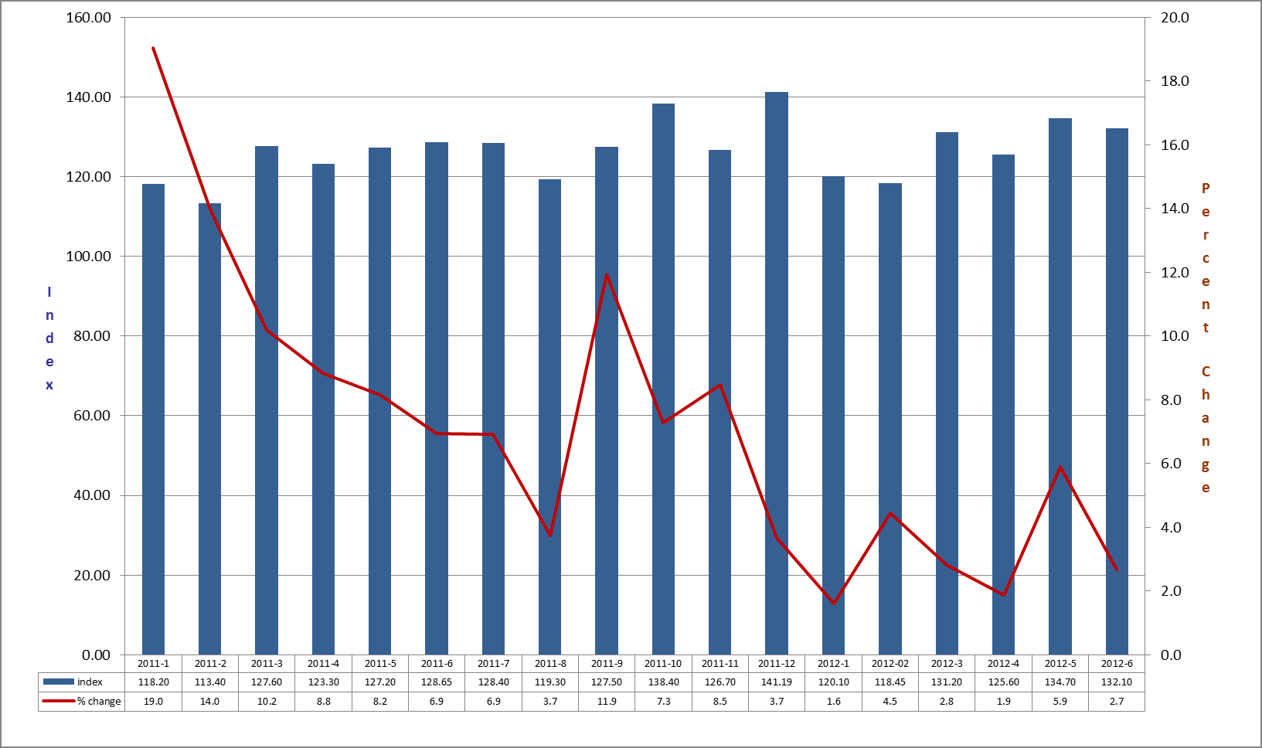
Source: TURKSTAT

➢ Industrial production index has increased by an average of 2,7%
annually as of June 2012, up to 132,1.

For further inquiries: info@yoikk.gov.tr 13
Capacity Utilization

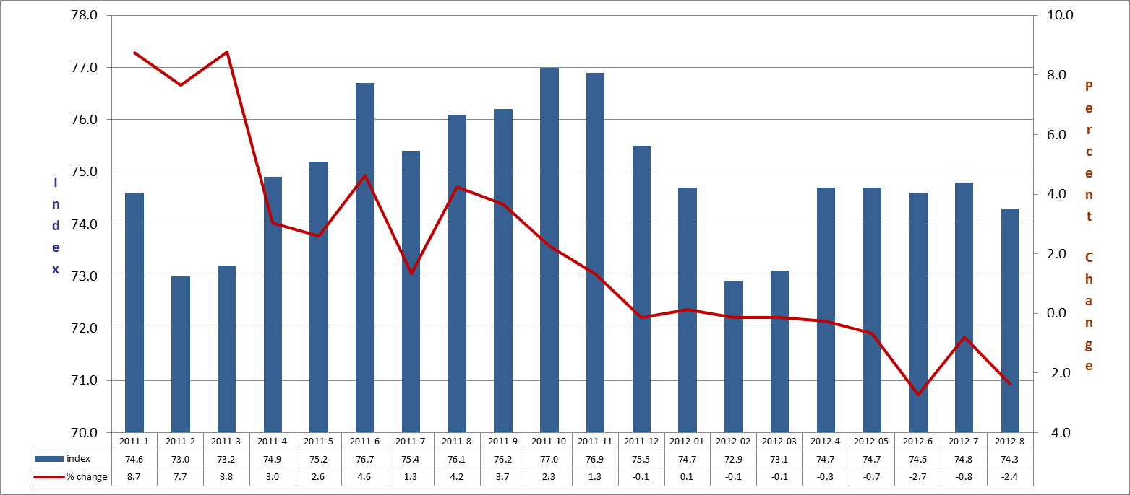

Source: TURKSTAT

➢ Capacity utilization ratio has been realized as 74.3% in August 2012.

For further inquiries: info@yoikk.gov.tr 14
Productivity

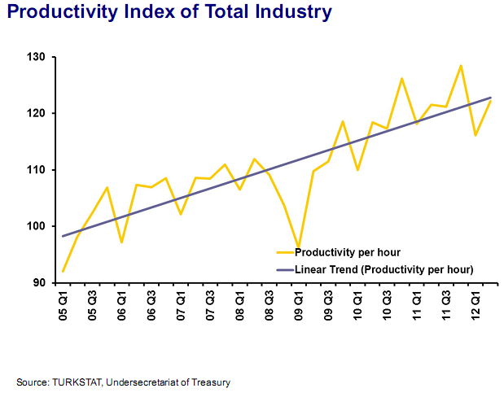

For further inquiries: info@yoikk.gov.tr 15
Budget Performance

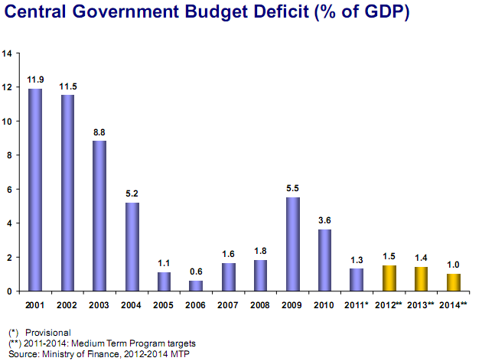

For further inquiries: info@yoikk.gov.tr 16
Budget Performance

2011

➢ EU defined general government budget deficit/GDP ratio was 2.6% in Turkey in 2011 and Turkey satisfied the Maastricht criteria of 3%. Turkey also outperformed 18 EU Countries.

➢ Central government budget deficit/GDP ratio was 1.3% in Turkey in 2011 and Turkey outperformed 23 EU Countries.

➢ In January-June 2012, central government budget deficit has been recorded as 6,7 billion dollars.
For further inquiries: info@yoikk.gov.tr 17
Debt Management

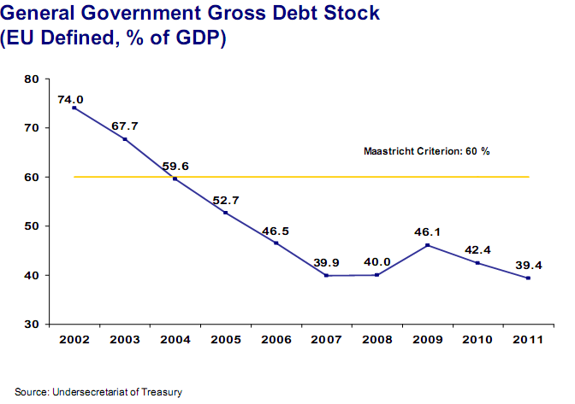

For further inquiries: info@yoikk.gov.tr 18
Debt Management

➢ Debt/GDP ratio of Turkey was 39.4% in 2011, which was below the level in 21 EU Countries and the Maastricht Criteria (60%).

For further inquiries: info@yoikk.gov.tr 19
Foreign Trade

60,0

50,0

40,0

37,7 38,5

41,0

39,4

42,4 42,9

45,7

39,6

40,7
48,7

30,0

20,0

10,0

0,0

2002 2003 2004 2005 2006 2007 2008 2009 2010 2011

➢ The ratio of foreign trade volume/GDP was 48,7% in 2011.

➢ Turkey’s integration to the international trade system is eminent.

For further inquiries: info@yoikk.gov.tr 20

Foreign Trade

EXPORT

(Million $) | An  2010 | nual  2011 | 2010/2011  Change.% | Periodic (Jan  2011 | uary-July)  2012 | 2011/2012  Change %
Investment Goods | 11.771 | 14.167 | 20,4 | 8.334 | 8.150 | -2,2
Intermediate Goods | 56.381 | 67.981 | 20,6 | 39.107 | 47.280 | 20,9
Consumption Goods | 45.321 | 52.252 | 15,3 | 29.728 | 31.493 | 5,9
Others | 411 | 555 | 35,0 | 278 | 289 | 4,0
TOTAL | 113.883 | 134.954 | 18,5 | 77.447 | 87.212 | 12,6

IMPORT

(Million $) | An  2010 | nual  2011 | 2010/2011  Change.% | Periodic (Jan  2011 | uary-July)  2012 | 2011/2012  Change %
Investment Goods | 28.818 | 37.268 | 29,3 | 21.875 | 19.621 | -10,3
Intermediate Goods | 131.445 | 173.135 | 31,7 | 100.597 | 102.798 | 2,2
Consumption Goods | 24.735 | 29.692 | 20,0 | 17.832 | 15.131 | -15,1
Others | 546 | 739 | 35,3 | 491 | 361 | -26,5
TOTAL | 185.544 | 240.833 | 29,8 | 140.796 | 137.912 | -2,0

For further inquiries: info@yoikk.gov.tr 21
Foreign Trade

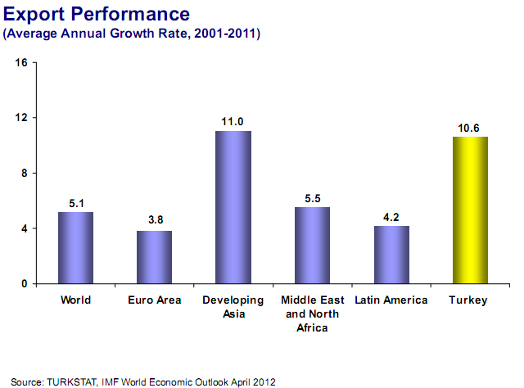

For further inquiries: info@yoikk.gov.tr 22
Foreign Trade

Share % Share % (Million $) 2010 2011 Change % (2011) 2011* 2012* Change % (2012*)
CIS 10,288 13,376 30.0 9.9 7,273 8,297 14.1 9.5
EFTA 2,416 1,887 -21.9 1.4 918 1,231 34.1 1.4
Economic Cooperation Organisation 7,617 9,292 22.0 6.9 5,140 11,742 128.4 13.5
Organization of Islamic Conference 32,470 37,325 15.0 27.7 20,792 31,716 52.5 36.4
Black Sea Economic Cooperation 14,456 17,768 22.9 13.2 9,872 10,400 5.4 11.9
FTA Countries** 12,694 13,602 7.2 10.1 6,522 7,154 9.7 8.2
OECD 61,491 71,616 16.5 53.1 39,516 38,023 -3.8 43.6
Turkic Republics 3,921 5,040 28.5 3.7 2,731 3,214 17.7 3.7
TOTAL 113,883 134,907 18.5 100.0 77,448 87,212 12.6 100.0

Source: TURKSTAT * January-July ** Except Lebanon and Mauritius

In January-July period of 2012, our exports to EFTA countries increased 34.1% and our exports to FTA countries increased 9.7% annually. The annual increase of our exports to ECO countries in the same period was 128.4% and ECO countries became the fastest growing export destination of the regions above.

For further inquiries: info@yoikk.gov.tr 23
Foreign Trade

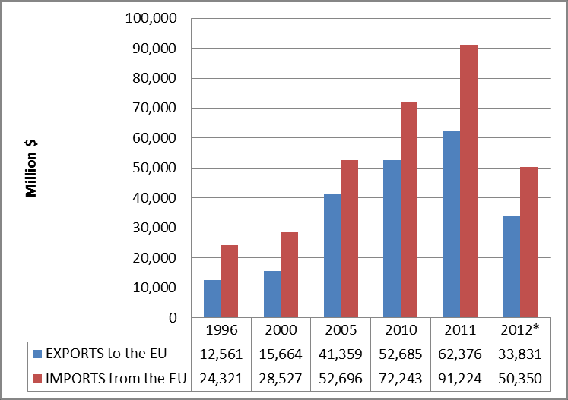

*January-July
Source: Data Source of the Ministry of Economy
For further inquiries: info@yoikk.gov.tr 24
Current Account Balance

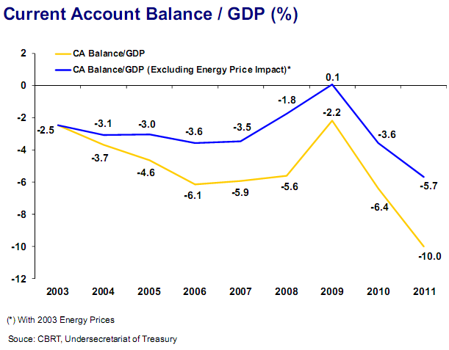

For further inquiries: info@yoikk.gov.tr 25
Current Account Balance

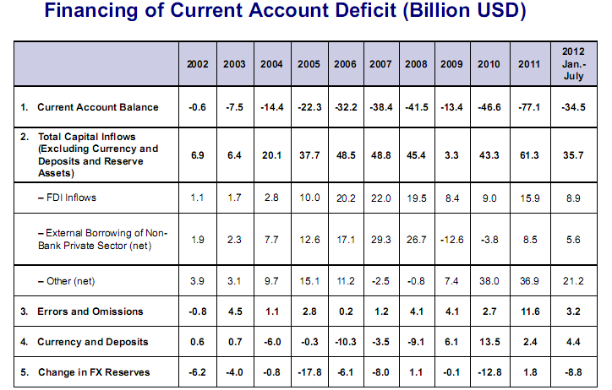

For further inquiries: info@yoikk.gov.tr 26
FDI Figures













 | FDI inflows (cumulative) | Companies with Intr.Capital (cumulative)
• 1923-2002 : | 15 billion USD | 6.000
• 2003-2011 : | 110 billion USD | 30.000

USD Billion


25
22,0
20,2
19,5

15,9

10,0 9,6
8,4 9,0

3,4
2,8
1,1 1,7

20

15

10

5

0
2001 2002 2003 2004 2005 2006 2007 2008 2009 2010 2011 2012


Jan-August


Source: Ministry of Economy, 2012 June



For further inquiries: info@yoikk.gov.tr 27


FDI Figures

Number of companies with Spanish Capital: 449

✓SPAIN – FDI CAPITAL INFLOW

2.500
2.230,0

838,0

583,0

145,0 205,0
5,0 0,0 3,0 66,0 53,0 52,0

USD Million

2.000


1.500

1.000

500

0

2002 2003 2004 2005 2006 2007 2008 2009 2010 2011 2012

Source: CBRT


For further inquiries: info@yoikk.gov.tr


FDI Outflows

✓Turkey is becoming a global player with increasing outward investments.

4 USD Billion

2,8

2,5 2,5

2,1

1,6 1,5

1,1
0,8 0,9

0,5 0,5

0,1

3

2

1

0

2001 2002 2003 2004 2005 2006 2007 2008 2009 2010 2011 2012

Jan-August

Source: CBRT, BOP Report
For further inquiries: info@yoikk.gov.tr

Economic Targets

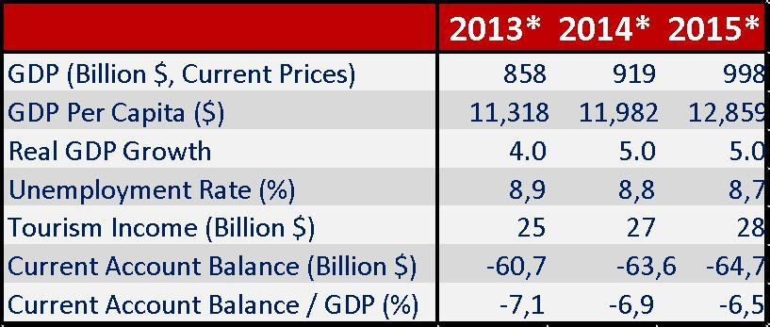

2023 TARGETS:

• 2 trillion dollars of Gross Domestic Product

• 25,000 dollars per capita GDP

• One of the ten biggest economies in the world

• 500 billion dollars of exports

For further inquiries: info@yoikk.gov.tr

Medium Term Programme aims to sustain economic growth, to decrease the current account deficit, and to preserve
macroeconomic and financial stability.

30

Contact Info:

Ministry of Economy

General Directorate for Incentive Implementation and

Foreign Investment

Ministry Phone: +90 312 204 6637

Counselor Phone: +34 91 310 4999

Fax: + 90 312 212 88 51

E-mail: info@yoikk.gov.tr

Web: www.economy.gov.tr

For further inquiries: info@yoikk.gov.tr

